Eel River Recovery Project Reports 2017 Pikeminnow Trends

The Eel River Recovery Project (ERRP) conducted a dive count of Sacramento pikeminnow in the South Fork Eel River from Rattlesnake Creek to Standish Hickey State Recreation Area on June 28-29 and is publishing a report of its findings. They carried out a similar dive in 2016. The number of pikeminnow was down somewhat in 2017, and there were few smaller ones, indicating poor reproduction during recent wet years.

Although flows during the two day dive were more than double those in 2016, conditions were still ideal for observing and counting fish. ERRP has a corps of seasoned volunteers who have participated in fall Chinook salmon dives since 2012. This group teamed up with two other divers from the U.S. Bureau of Land Management (BLM) Arcata Field Office and four divers affiliated with the U.C. Berkeley Angelo Reserve.

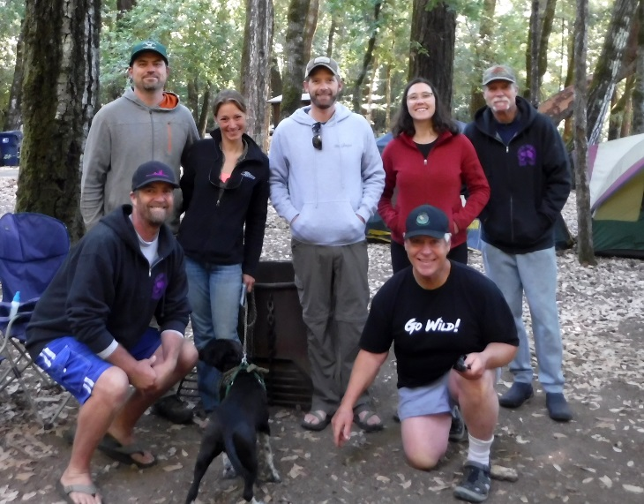  Day 1 ERRP dive team: In front Eric Stockwell (l) and Pat Higgins (r), and Willie Grover, Tara Tompkin, Zane Ruddy, Emily Maloney and Dave Sopjes. | 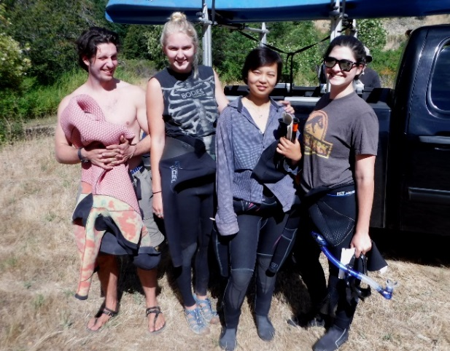  UC Berkeley volunteers on Day 2: Phil Georgakakos, Kristin Shikella, Garbo Gin, and Veronica Uva.

The number of pikeminnow counted in 2017 was 1173, which is down from the 1414 counted in 2016 when ERRP collected baseline data. Adults larger than 18 inches, which are of greatest concern because of their voracious predation, declined from 134 to 90. However, 14-18 inch pikeminnow are also formidable predators and they increased to 389 in 2017 from only 111 the previous year. These fish were likely born during the prolonged drought from 2013 to 2015 when warm water would have favored their survival and growth. Pikeminnow less than 8 inches were less abundant, indicating poor recruitment over the last 2 years. This is probably because high cold flows inhibit spawning and impede growth and survival of juveniles.

The largest adult pikeminnow were observed in different locations in 2017. Many were seen in runs and shallow pool habitats, but in 2016, more than 80% of the large fish were in just four deep pools. This year, the adults are taking advantage of high water to actively pursue juvenile steelhead. ERRP will do a spot check on some of the largest pools later in the summer to see if big pikeminnow retreat there as flow drops.

Intense predation by families of otters seems to drive the pikeminnow into in very deep pools, where the fish can out-swim the otters, or around submerged large woody debris, where they can hide. ERRP has confirmed this pattern of distribution elsewhere during dives at Holmes Flat on the lower Eel, on the upper Eel at Hearst and Dos Rios, and in the Middle Fork and Black Butte rivers.

The 2017 report and video of pikeminnow reconnaissance are posted at www.EelRiverRecovery.org. Photos are also on the ERRP Facebook page.
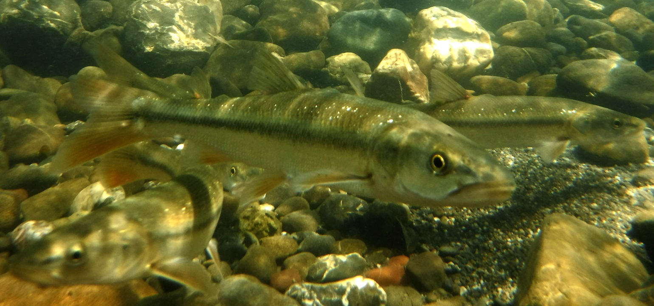
Pikeminnow 8-14 inches long in a riffle above the Holmes Bluff Pool. 7/10/17.

The pikeminnow has long been recognized as a threat to native salmon and steelhead of the Eel River and agency planning documents and reports have called for their removal, but no organized effort has been expended in doing so. Pikeminnow also prey upon other native fish species, like the Sacramento sucker that feed on algae and sculpin species that live among the rocks. Only two suckers over four inches were seen during the survey and no sculpin were seen.

ERRP is intent on getting permits from regulatory agencies for strategic pikeminnow removal, where experienced spear fishermen would target only the largest adults. These adults are not only the top predators, but also are typically females and have tremendous reproductive capacity. If efforts to remove the largest adults continue for 10 years, the typical life expectancy of pikeminnow, then the population may be permanently suppressed. Since there was a change in distribution of large adults in 2017, ERRP will be collecting another year of trend data in 2018 and requesting a permit to take pikeminnow in 2019.

If you see groups of large pikeminnow, or other fish ERRP invites you to call (707) 223-7200 to share your information or share photos on our Facebook page.

